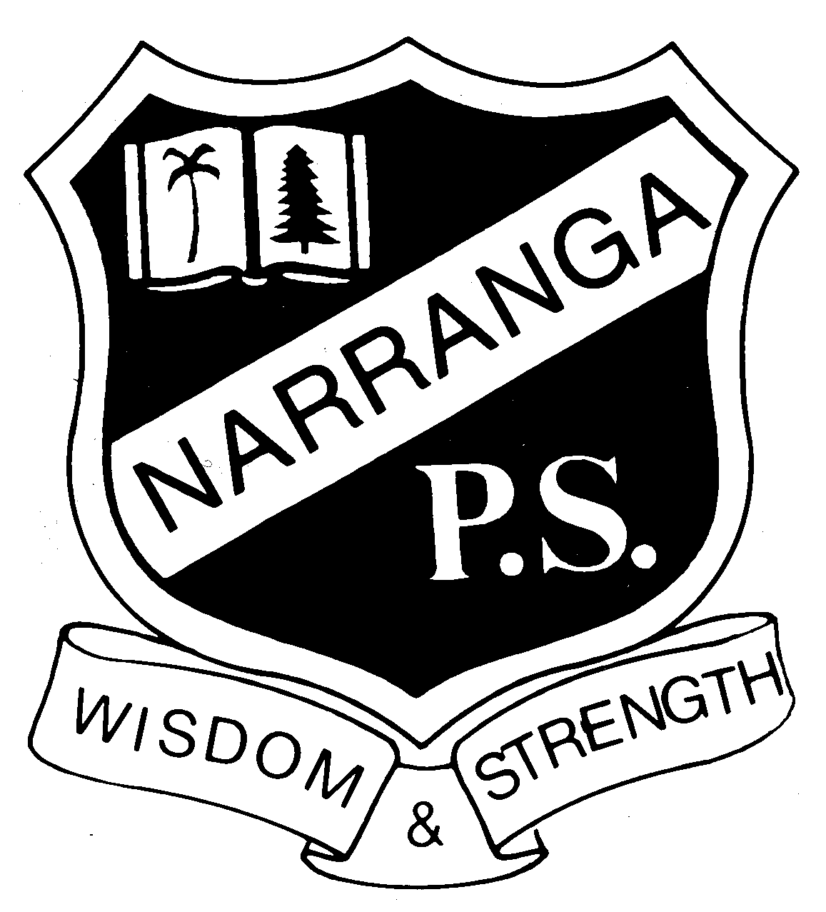
NARRANGA PUBLIC SCHOOL

26/1/2022
Dear parents and carers
Welcome to a new school year, an exciting time as our students start or return to their school journey. I want to share how we are building on our experiences of the last 2 years and continuing to safeguard our school community while keeping our school open, where we know the best learning happens.
We will start 2022 with a layered approach to COVID-smart measures that have been developed in partnership with NSW Health to help to minimise transmissions at school. The health and wellbeing of our students and staff remain our priority, and these measures are designed to help to keep our school open and our students learning in the classroom.
These key measures include:
- Rapid antigen test (RAT) kits will be provided to all students to help monitor your child’s health and minimise transmission of COVID-19 across our school.
- Wearing of surgical masks indoors is required for all staff and students in Year 7 and above and strongly recommended for all primary students. Masks will be provided by the school if required.
- Only fully vaccinated visitors essential to delivering and supporting learning or wellbeing can come on a school site.
- Two parents or carers are allowed to accompany their child into school on their first day of Kindergarten or Year 7 or students starting at a new school.
- Students will be kept in their stage groups on school grounds, to minimise the spread of COVID-19 across cohorts.
- We will continue to use good hygiene, enhanced cleaning, good air flow and ventilation in learning spaces, as well as physical distancing practices.

While this is not going to be a normal start to the school year, we know that being together in the classroom is the most effective way for students to learn and grow. Your child's relationship with their teacher is important, but as we manage potential disruptions to staffing due to COVID-19, they may get to meet more teachers than usual.

Rapid antigen testing
We will distribute rapid antigen test (RAT) kits for all students and staff at the start of Term 1.
The use of RAT kits is an important step to support the health and wellbeing of our students and staff. They are a quick and easy screening tool to help detect COVID-19. It is a simple process of placing a nose or throat swab in a chemical solution, which is put onto a scanning device. Results can be ready within 15 minutes. Use of RAT kits is highly recommended but not mandatory.
Instructions are included in the kits detailing how to use the tests, check the results and dispose of the tests safely. You can also download the instructions through the Therapeutic Goods Administration (TGA)External link website. The user guides will also contain a contact number for the suppliers if you need additional support.

How and when do I pick up the RAT kits?
- We anticipate that Narranga’s RAT kits will arrive at school on Thursday January 27. We hope to have them available for parents to pick up from the front of the school on Friday 28 & Monday 31.
- We will confirm these dates and add times via the school Facebook page as soon as possible.
- We expect that parents will receive a pack of 4 RAT kits per student – enough to last for the first 2 weeks of school. Parents and carers are requested to leave the school site immediately after picking up their packs of RAT kits.

Additional information
- School staff will not be administering the rapid antigen tests to students.
- RAT kits should be collected from school by a parent or carer and the tests completed at home in the morning before attending school.
- Each student will receive an initial supply of 4 RATs to be used twice a week in the morning before attending school.
- If a student or staff member receives a positive RAT result, they need to:
  - record the positive RAT result through the Service NSW websiteExternal link or Service NSW appExternal link
  - notify the school of the positive RAT or PCR result as soon as possible
  - follow NSW Health adviceExternal link to isolate for 7 days. Negative results do not need to be reported to Service NSW or to the school.

Unwell at school
Any student or staff member who is unwell and/or displays symptoms of COVID-19 will be asked to go home and stay until they can complete a RAT or PCR test.
- If symptoms continue, they should stay at home and take another RAT in 24 hours or have a PCR test.
- If the second RAT or initial PCR test result is negative and they are displaying no symptoms OR they are diagnosed as another condition such as hayfever, the student or staff member can return to school.

What happens when a student or staff member tests positive for COVID-19
Under the new close contact rules, schools are no longer included in contact tracing. I will inform the school community when there is a positive case in our school and advise families on public health advice, including monitoring for symptoms.

Use of surgical masks
All primary and secondary school staff will be required to wear masks indoors.
No vented or cloth masks should be worn. If required surgical masks will be available at schools.
Primary school students are strongly recommended to wear well-fitted masks indoors.
Masks are also strongly encouraged in outdoor settings where you cannot physically distance. Your child can remove their mask when eating, exercising or playing a musical instrument.
For more information, refer to Face masks in NSWExternal link.

Visitors on school sites and vaccinations
No parents, carers or visitors will be allowed on school site until further notice with the following exceptions:
- Two parents or carers are allowed to accompany their child into school on their first day of Kindergarten or Year 7 or students starting at a new school.
- Volunteers or staff operating uniform shops and canteens must be fully vaccinated.
- Visitors supporting school operations and curriculum delivery must be fully vaccinated.
- Allied health partners for the wellbeing of students must be fully vaccinated.
All staff on school sites are required to be fully vaccinated, including having their booster when eligible.
We strongly encourage our students and their families to consider vaccination when eligible. Find a vaccination clinicExternal link to book an appointment near you.

Other key measures

Ventilation
We will continue to follow NSW Health ventilation guidelines that natural ventilation is the most effective measure so we will maximise fresh air flow in learning spaces through opening doors and windows.
This approach is strongly supported by expert advice. Where natural ventilation is not sufficient, mechanical ventilation and/or air purification may be used and we will continue to use outdoor settings when suitable.

Cleaning
We continue to have enhanced cleaning focusing on high-touch and high-traffic areas.

Physical distancing
We will continue to follow physical distancing guidelines and maintain 1.5 metres distance wherever possible..
Thank you again for your continued support during this school term.
Michael Trist
Principal

